**28/09/2021 CD LAB 4 2019103573**

**EXECUTION – EXCERSISES**

**IMPLEMENTATION OF A LEXICAL ANALYSER USING LEX**

**1.Write a lex program that replaces the substring abc by ABC from the given input string.**

**CODE :-**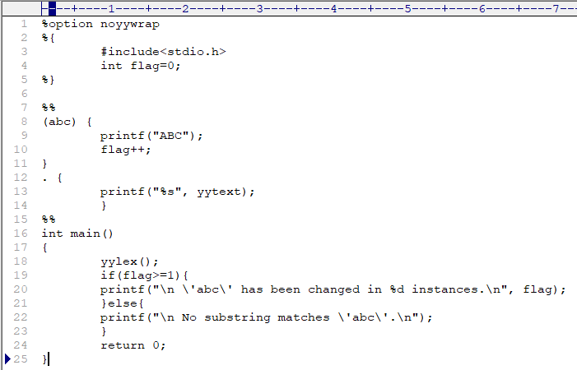

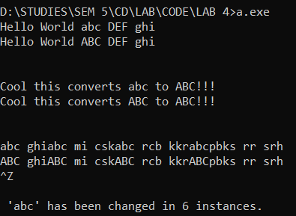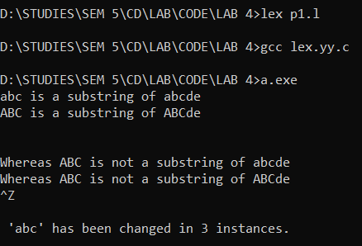**OUTPUT :-**

**2.Write a lex program to identify whether a given Well formedness of bracket.**

**CODE :-**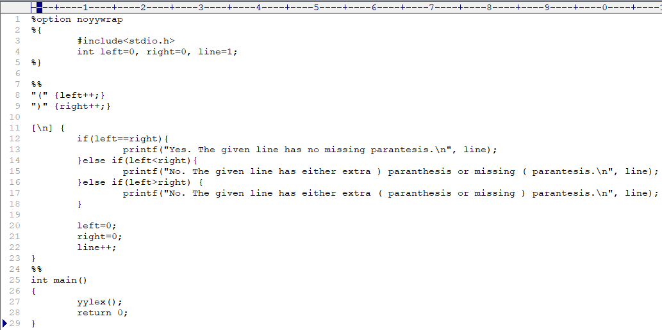

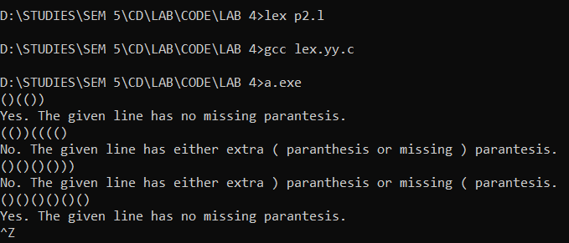**OUTPUT :-**

**3.Write a lex program to finding vowels and consonant in a string.**

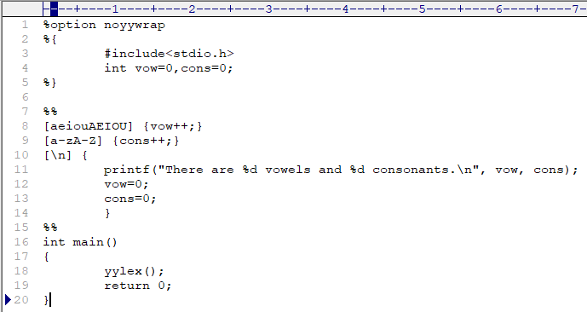**CODE :-**

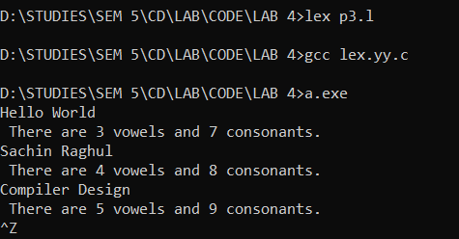**OUTPUT :-**

**4.Write a lex program to finding the capital letter in given input string.**

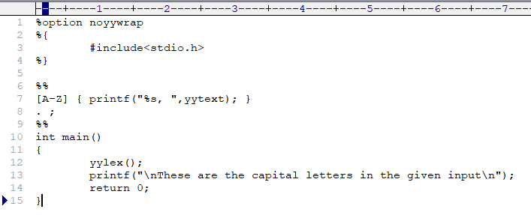**CODE :-**

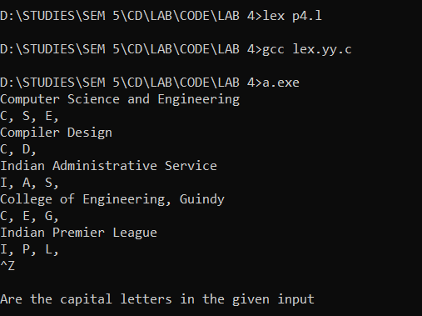**OUPUT :-**